

**Name** : KAUTA MARVIN

**Registration Number** : S20B23/204

**Faculty/School** : SCIENCE AND TECHNOLOGY

**Course** : BACHELORS OF SCIENCE IN COMPUTER SCIENCE

**Lecturer** : ***mR LUBAMBO SIMON***

**ASSUMPTIONS**

**FUNCTIONALITY / HUMAN ASSUMPTIONS**

**These assumptions will help us know what functionalities will be in the system that is being developed to suit their needs**

1. There is an assumption that in every society there must be visually impaired persons (VIPs) or temporally blind that these kinds of people have helpers to help them in their daily life activities.
2. There is an assumption that communication with others is limited between these kinds of people because of their disabilities.
3. There is an assumption that these people at some point would like to read/write/send messages to other people.
4. There is an assumption that the VIPs Must move from one place to another either with or without help.
5. There is an assumption that these people also get bored and would love to get some entertainment either music or a talk with someone else.
6. There is an assumption that the helper of the VIPs must know the exact location of the VIP
7. There is an assumption that areas that are helping these kinds of people are already there. These areas will help the developers in testing and collecting more research information.

**TECHNOLOGICAL ASSUMPTIONS**

**There is an assumption that:**

1. The developers for this project already know the current technologies like flutter, firebase, Artificial intelligence knowledge, natural language processing
2. The developers have done a similar project before.
3. The developers can work in teams and alongside the Visually impaired so that they develop alongside them.
4. Enough data has been collected to use in the development of the system
5. There is an assumption that each user will have to access the system with a mobile phone and an active internet service plan
6. The user is assumed to have a helper with the sister app on their application
7. We assume that each user will avail personal data that is same as the one at NIRA(for uganda’s case )

**FINANCIAL ASSUMPTIONS**

1. There is an assumption that the clients will be able to subscribe to the services being offered.
2. There is an assumption that due to the population statistics, trained people will be employed and trained on how to help the visually impaired people which will increase the revenue within a short period
3. There is an assumption that funds to facilitate the development of the system are available.

**WORK PLAN / DEVELOPMENT SCHEDULE**

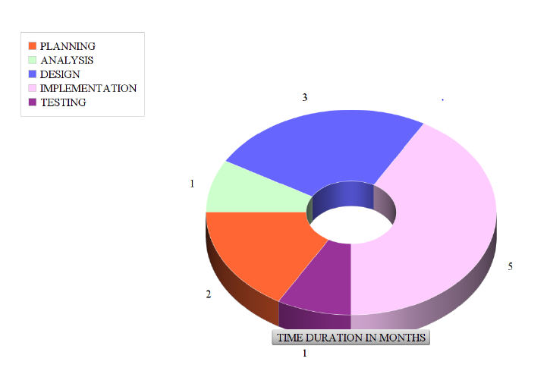

**ESTIMATED BUDGET**

|  |  |  |  |  |  |
| --- | --- | --- | --- | --- | --- |
| **No** | **Type of hardware** | **Use** | **Quantity** | **Unit price** | **total** |
| 1 | Laptop computer | To research, design, develop and document the system. | 2(refurbished) | 1000000 | 2000000 |
| 2 | 1TB hard disk | To transfer files,  For offline backup of the system | 2 | 150,000 | 300000 |
| 3 | Printer | To print documents | 1 | --------- | --------- |
| 4 | Smart phone | For research and testing the system | 2 | 300000 | 600000 |
| 6 | Modem | Alternative for internet connection | 1 | 50000 | 50000 |
| 7 | Algorithm subscriptions | For accesing API keys and webhooks  For the algorithms | 3 | 150000/month | 450000 |
| 8 | Webhook and cloud servies | To access cloud services like voice recognition algorithms online | 1 | 150000 | 150000 |